**User Manual**

**Customer Application Form**

**Steps:**

1. Fill/select every field, except Number of Guests(Optional)
2. Click “NEXT:STATEROOM>” to proceed to next page
3. Select Cabin number and type, there is a Legend for reference of cabin type
4. If there are additional guests, fill/select all fields
5. Click “GENERATE INVOICE” button
6. Click “EXIT” to end application and a new application will restart itself

**Trip Itinerary Form**

**Steps:**

1. Set the itinerary ID in the cruise control form
2. Click on the itinerary control button to open the trip management form

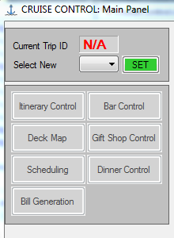

Editing a day:

1. Select a row in the datagridview on the trip management form

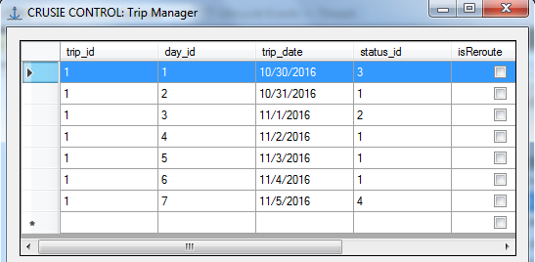

1. Click the edit day button



1. Change data on the edit day form
2. Click the edit day button on the edit form to finalize changes

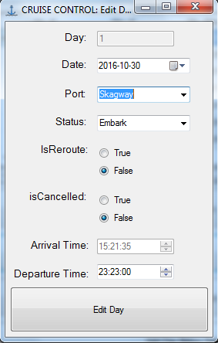

1. Click the reload day’s button on the trip management form to see the updates

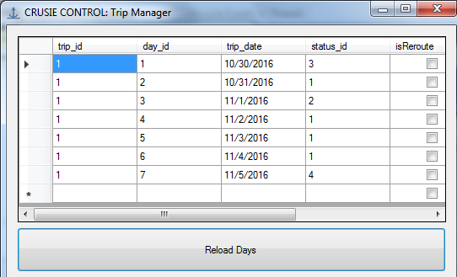

Adding a new day:

1. Click the add new day button on the trip management form



1. Fill the form with data

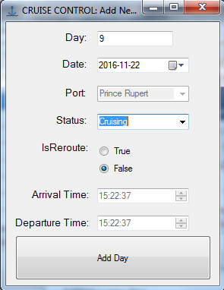

1. Click the add day button on the add day form
2. Click the reload day’s button on the trip management form to see the updates

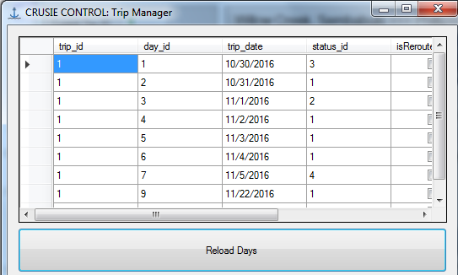

Adding a new day below a selected row:

1. Select a Row on the trip management form

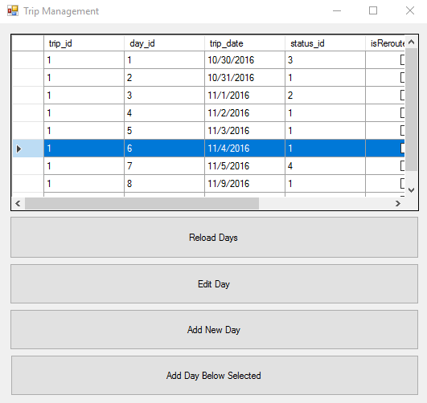

1. Click the add day below selected button



1. Fill the form with data

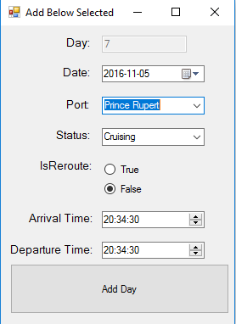

1. Click the add day below selected button on the add below form
2. Click the reload day’s button on the trip management form to see the updates

